Name

Mathematics Stage 5 Core
Multistage Probability

Book 1 |  | Version: 261002  Feedback:  https://MrDingMaths.com
Contents
Syllabus Content 2
Learning Intention 3

Syllabus Content
MA5-PRO-C-01 solves problems involving probabilities in multistage chance experiments and simulations
Describe multistage chance experiments involving independent and dependent events
- Explain the difference between dependent and independent events in experiments involving 2 stages
- Explain how the probability of independent and dependent events differs in relation to replacement
Solve problems for multistage chance experiments
- Record all possible outcomes for multistage chance experiments
- Determine the probabilities of outcomes for multistage independent events using $P\left(A and B\right)=P\left(A\right)×P\left(B\right),$ where necessary
- Determine the probabilities of outcomes for multistage dependent events
- Associate complementary events with probabilities in multistage chance experiments

Independent and Dependent Events

- Multistage Experiments
A multistage experiment consists of two or more steps.
For example:
- rolling two dice
- flipping three coins
- flipping a coin, then rolling a die, then picking a card from a deck.

- Independent and Dependent Events
An independent event doesn't change based on previous results.
Example: Flipping a coin twice - the second flip doesn't depend on the first.
A dependent event changes based on previous results.
Example: Taking two marbles from a bag - the second pick depends on the first.

- Identify events as independent or dependent.
- Tossing a coin then tossing another.  - Independent  - Dependent | - Rolling a die then rolling another.  - Independent  - Dependent
- Picking a card from a deck, then picking another one without replacing it.  - Independent  - Dependent | - Picking a card from a deck, replacing it, then picking another card after shuffling.  - Independent  - Dependent
- Tossing a coin then rolling a die.  - Independent  - Dependent | - Choosing a marble from a jar, replacing it, shaking the jar, then choosing another.  - Independent  - Dependent
- Choosing a chocolate from a box,  eating it, then choosing another.  - Independent  - Dependent | - Choosing a marble from a jar then choosing another marble.  - Independent  - Dependent
When an experiment is conducted with replacement, is it independent or dependent?

When an experiment is conducted without replacement, is it independent or dependent?

Foundation
- Identify these events as independent or dependent.
- You roll a six-sided die and then flip a fair coin. | ………………  I
- You have a bag with red marbles and blue marbles. You draw a marble, note its color, and then draw another marble without replacement. | ………………  D
- You draw a card from a standard deck and record its suit. You replace the card and shuffle the deck, then draw a second card from the deck. | ………………  I
- You have a drawer with black socks and white socks. You select a sock, record its color, and then select another sock without replacement. | ………………  D
- You check the weather forecast in the morning, and based on that information, you decide whether to bring an umbrella. | ………………  D

- A fair coin is tossed 10 times. It comes up heads 9 times.
What is the probability it will be heads on the 10th toss? Why?
………………………………………………………………………………………………………………
$\frac{1}{2},$as coin tosses are independent events.
- A bag contains a red jellybean and a blue jellybean.
Scenario 1: A jellybean is drawn randomly, the colour recorded, and then returned to the bag. Afterwards, a second jellybean is drawn.
Scenario 2: A jellybean is drawn randomly, the colour recorded, and it is then eaten.
Afterwards, a second jellybean is drawn.
  - Out of the two scenarios, which one represents a series of independent events,
and which one represents a series of dependent events?

Scenario 1 is independent, Scenario 2 is dependent
  - In scenario 1, explain why the probability that the second jellybean is red is $\frac{1}{2}$,
regardless of the colour of the first jellybean.

Jellybean draws are independent events
  - In scenario 2, explain why the probability of the second jellybean being red will not be $\frac{1}{2}$.
If a red jellybean was taken first, the probability of the second being red will be 0
If a blue jellybean was taken first, the probability of the second being red will be 1

Listing Outcomes using Tables

- Fundamental Counting Principle for Independent Events
For two independent events:
If one event can occur in $m$ ways and another event can occur in $n$ ways,
then both events can occur in $m × n$ ways.

- Calculate total number of outcomes.
- Timmy has two shirts and three trousers.
How many outfit combinations can he have?
$2×3=6$

- Tammy has three shirts and five skirts.
How many outfit combinations can she have?

- A restaurant offers a three-course set menu.
Starter: 3 options | Main: 5 options | Dessert: 2 options
How many meal combinations are there?

- A student ID has six characters. It starts with an English letter and has five digits.
How many students can this ID system support?

- A dice is rolled and a coin is flipped.
How many possible outcomes are there?

- Two dice are rolled and a coin is flipped.
How many possible outcomes are there?

- Listing Outcomes using Tables
A two-way table to records all possible combinations of outcomes for a two-step experiment.
- Use the fundamental counting principle to check you have recorded all possible ways.

- Example List all possible outcomes using a two-way table.
Two four-sided die are rolled and then their results are added.
Complete the table to list all outcomes
 |  | Dice 2
 |  | 1 | 2 | 3 | 4
Dice 1 | 1 | 2 | 3 | 4 | 5
Dice 1 | 2 | 3 | 4 | 5 | 6
Dice 1 | 3 | 4 | 5 | 6 | 7
Dice 1 | 4 | 5 | 6 | 7 | 8

- How many outcomes are there? 16
- What is the probability that the dice sum is 4? $\frac{3}{16}$
- What is the probability that the dice sum is 5 or greater? $\frac{10}{16}=\frac{5}{8}$

- Practice
A two-step experiment involves flipping a coin then rolling a die.
Complete the table to list all outcomes.
 |  | Dice
 |  | 1 | 2 | 3 | 4 | 5 | 6
Coin | H
Coin | T

- What is the total number of outcomes?
12
- What is $P\left(tail\right)$?
$$\frac{1}{2}$$
- What is $P\left(head and 4\right)$?
$$\frac{1}{12}$$
- What is the probability of a head and an odd number?
$$\frac{1}{4}$$

- Example List all possible outcomes of dependent events using a two-way table.
Two letters are taken from the work TREE without replacement.

Complete the table to list all outcomes
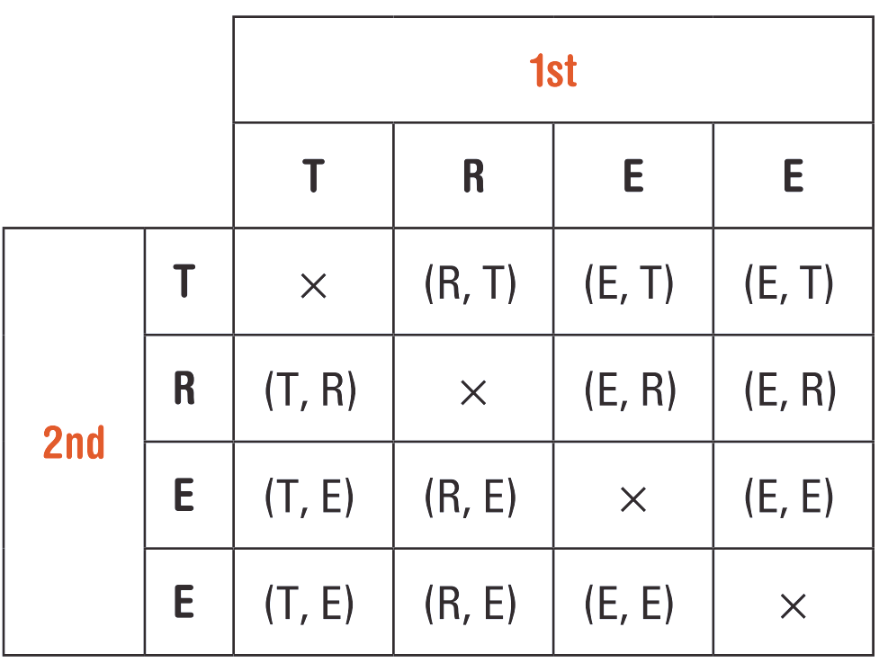

- Practice
Complete these tables to show all possible outcomes.
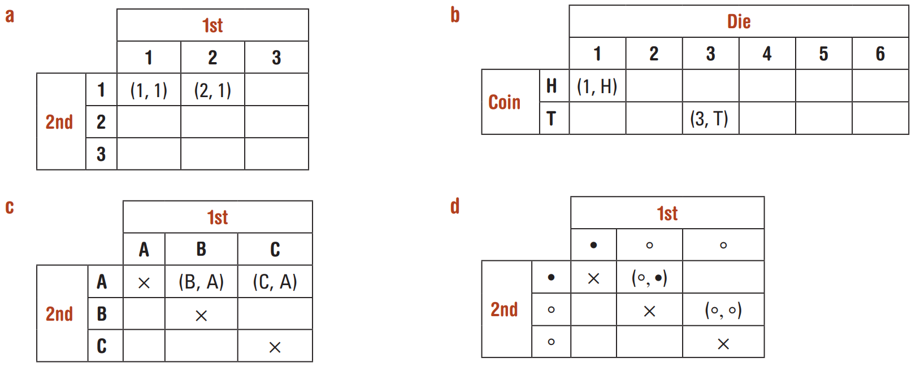  - Picking cards numbered 1, 2, 3 out of a bag with replacement. | - Rolling a die and flipping a coin.
- Picking cards numbered A, B, C out of a bag without replacement. | - Picking marbles out of a bag with 1 black and 2 white marbles without replacement.

Foundation
- This is a two-way table for rolling two dice and adding the results.
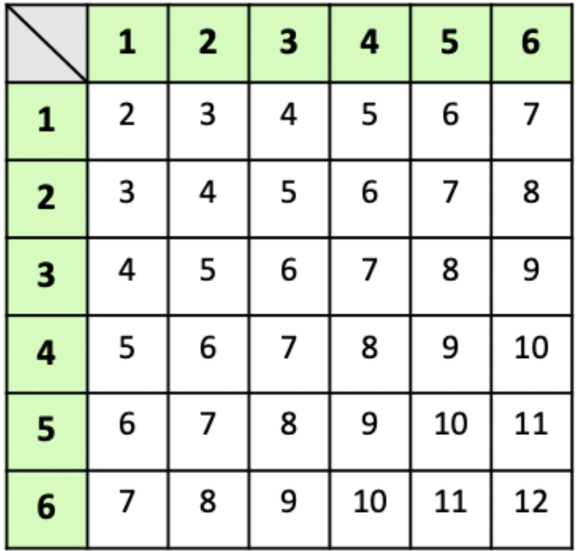
  - How many possibilities are there in total?
$$6×6=36$$
  - How many of these add up to 8?
5
  - What it the probability of scoring an 8?
$$\frac{5}{36}$$
  - What is the most likely result?
Getting a sum of 7
  - What is the probability of this result?
$$\frac{6}{36}=\frac{1}{6}$$

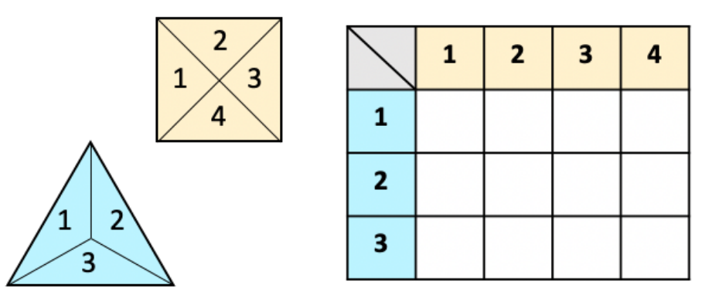
- Complete this two-way table for rolling these two spinners and then adding their results.
What is the probability of scoring
  - 6?
$$\frac{2}{12}=\frac{1}{6}$$
  - 7?
$$\frac{1}{12}$$
  - 6 or 7?
$$\frac{1}{6}+\frac{1}{12}=\frac{1}{4}$$

- The total sum is recorded from rolling two four-sided dice.
  - Complete the table.
 |  | Die 2
 |  | 1 | 2 | 3 | 4
Die 1 | 1 | 2 | 3 | 4 | 5
Die 1 | 2 | 3 | 4 | 5 | 6
Die 1 | 3 | 4 | 5 | 6 | 7
Die 1 | 4 | 5 | 6 | 7 | 8

  - Find the probability that the outcome is:
- 2  $$\frac{1}{16}$$ | - 2 or 3  $$\frac{3}{16}$$ | - Less than or equal to 4  $$\frac{3}{8}$$ | - More than 6  $$\frac{3}{16}$$

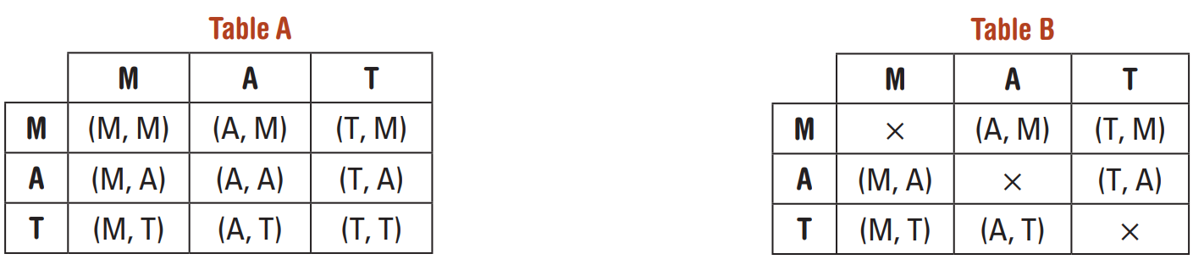
- These two tables list the outcomes for the selection of two letters from the word MAT.

  - Which table shows selection where replacement is allowed (with replacement)?
Table A
  - Which table shows selection where replacement is not allowed (without replacement)?
Table B
  - What is the probability of choosing the outcome (T, M) from:
    - Table A
$$\frac{1}{9}$$
    - Table B
$$\frac{1}{6}$$
- Two four-sided dice (numbered 1, 2, 3, 4) are rolled.
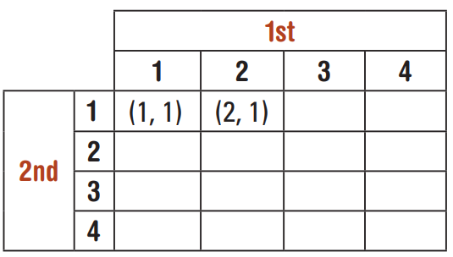
  - Complete the table to list the outcomes.
  - Find the probability of obtaining (2, 3).

  - Find P(double). A double is an outcome with
two of the same number.

- A six-sided die is rolled twice.
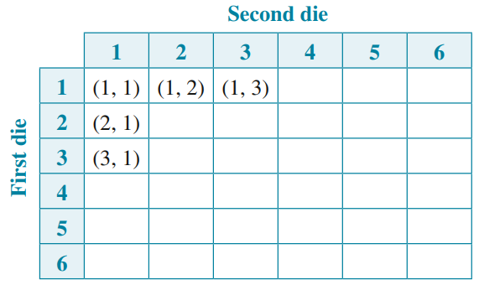
  - How many possible outcomes are there?
36
  - What is the probability of rolling a double?
$$\frac{1}{6}$$
  - What is the probability of not rolling a double?
$$\frac{5}{6}$$
  - What is the probability of rolling a 2 and a 3, in any order?
$$\frac{1}{18}$$
  - What is the probability of rolling two odd numbers?
$$\frac{1}{4}$$

  - What is the probability of rolling a sum of 5?
$$\frac{1}{4}$$

Development
- A coin is tossed and a six-sided die is rolled. List all the outcomes using a table.

Find the probability of:
  - a head and a 6
$$\frac{1}{12}$$
  - A tail and a 3
$$\frac{1}{12}$$
  - A head and an even number
$$\frac{1}{4}$$
  - A tail and a number less than 3
$$\frac{1}{6}$$

- Jill guesses the answers to two multiple-choice questions with options A, B, C, D or E. Fill in the table.
The answers were A for the first question and D for the second.
What is the probability that Jill will get:
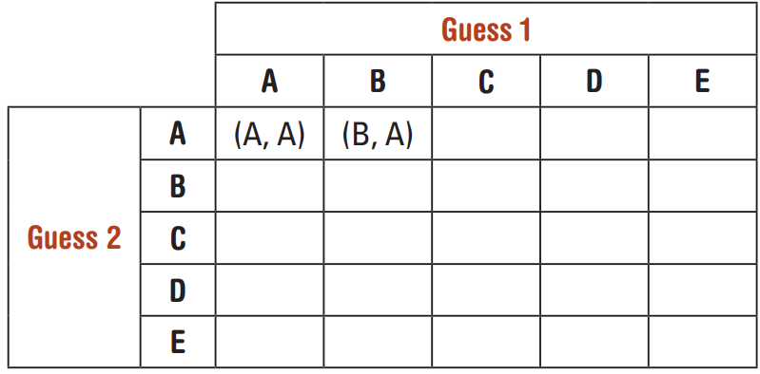
  - Both answers correct

$$\frac{1}{25}$$
  - Only one answer correct

$$\frac{8}{25}$$
- Two fair dice are rolled. The numbers of the dice are added together.
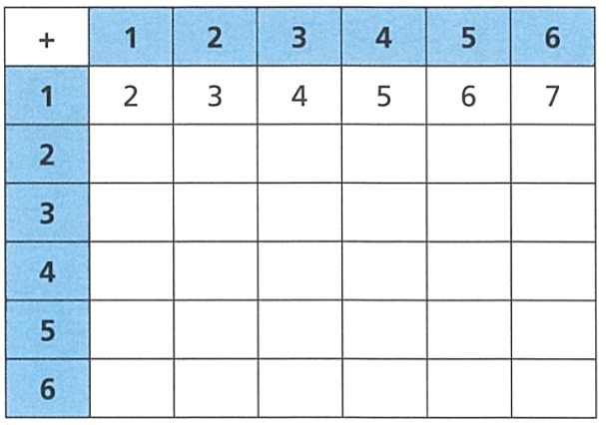
  - What is the probability of rolling a score of 8?
$$\frac{5}{36}$$
  - What is the probability of rolling a score greater than or equal to 10?
$$\frac{1}{6}$$
  - Which is more likely, rolling a score of 7 or rolling a score less than 4?

$$P\left(7\right)=\frac{6}{36}, P\left(<4\right)=\frac{3}{36}$$
Rolling 7 is more likely
- 2023 HSC standard 2 Band 3
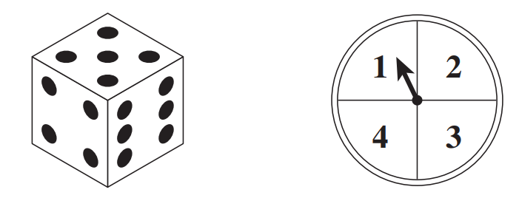
A game involves throwing a die and spinning a spinner.
The sum of the two numbers obtained is the score.
The table of scores below is partially completed.
What is the probability of getting a score 7 or more?
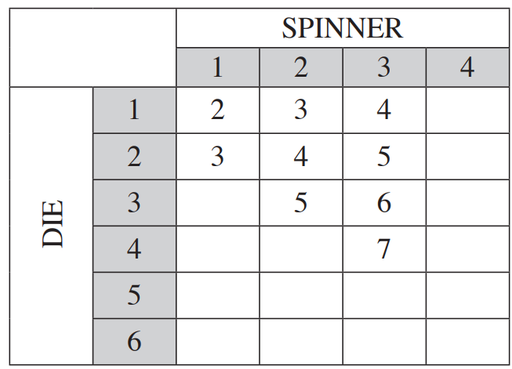

$$\frac{10}{24}=\frac{5}{12}$$
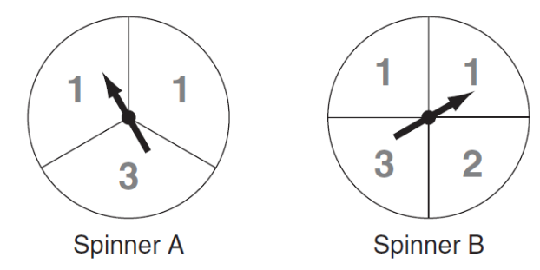
- 2011 HSC Standard 2 Band 4
The two spinners shown are used in a game.
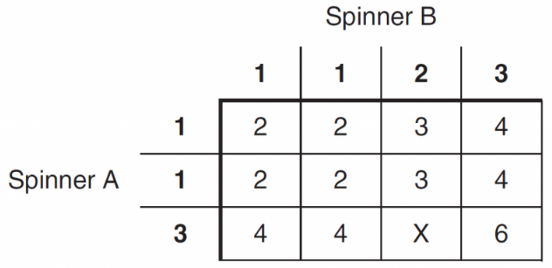
Each arrow is spun once. The score is the total of the two numbers shown by the arrows.
A table is drawn to show all scores that can be obtained.

  - What is the value of X in the table?
5
  - What is the probability of obtaining a score less than 4?

$$\frac{6}{12}=\frac{1}{2}$$
  - On Spinner B, a 2 is obtained. What is the probability of obtaining a score of 3?

$$\frac{2}{3}$$

Listing Outcomes using Tree Diagrams

- Listing Outcomes using a Tree Diagram
A tree diagram records all possible combinations of outcomes for a multistage experiment.
Branches represent each possible outcome at every stage.
Outcomes are listed at the end of each complete path.
- Use the fundamental counting principle to check you have recorded all possible ways.

- Example Construct a tree diagram
A fair coin is tossed three times. Use a tree diagram to list all possible outcomes.
1st Toss | 2nd Toss | 3rd toss | Outcomes
H  T | T  H  H  T | H  T  H  T  H  T  H  T | HHH  HHT  HTH  HTT  THH  THT  TTH  TTT
- How many outcomes are there? 8
- What is the probability of two heads and a tail, in that order? $\frac{1}{8}$
- What is the probability of two heads and a tail, in any order? $\frac{3}{8}$

- Practice
A bag contains 2 red discs and 1 green disc. A coin is tossed, and a disc is randomly chosen.
Coin Toss | Pick Disc | Outcomes
- How many outcomes are there?
6
- What is the probability of getting tails and a red disc?
$$\frac{1}{3}$$
- What is the probability of getting a red disc?
$$\frac{2}{3}$$

Foundation
- A coin is tossed twice.
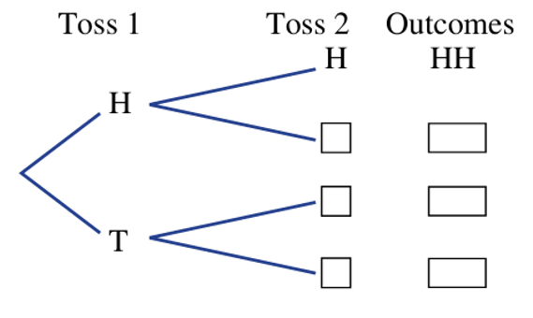
  - Complete this tree diagram to show all the possible outcomes.

All outcomes are HH HT TH TT
  - What is the total number of outcomes?
4
  - Find the probability of obtaining:
- two heads  $$\frac{1}{4}$$ | - one head  $$\frac{1}{2}$$ | - at least one head  $$\frac{3}{4}$$ | - at least one tail  $$\frac{3}{4}$$

- A drawer contains two red socks (R), one blue sock (B) and one yellow sock (Y).
Two socks are selected at random without replacement.
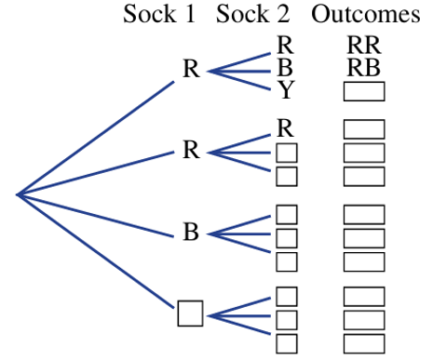
  - Complete this tree diagram.

  - Find the probability of obtaining:
- a red sock and a blue sock  $$\frac{1}{3}$$ | - two red socks  $$\frac{1}{6}$$ | - any pair of socks of the same colour  $$\frac{1}{6}$$ | - any pair of socks of different colour  $$\frac{5}{6}$$

- Explain why this is incorrect:
“When two coins are tossed together, there are three events: two heads, two tails and one of each. Hence the probability of getting one of each is $\frac{1}{3}$”
There are two ways to get one of each: HT and TH, so it is $\frac{2}{4}=\frac{1}{2}$
- Complete each tree diagram for the experiments without replacement.
- Selecting two letters from the word TWO  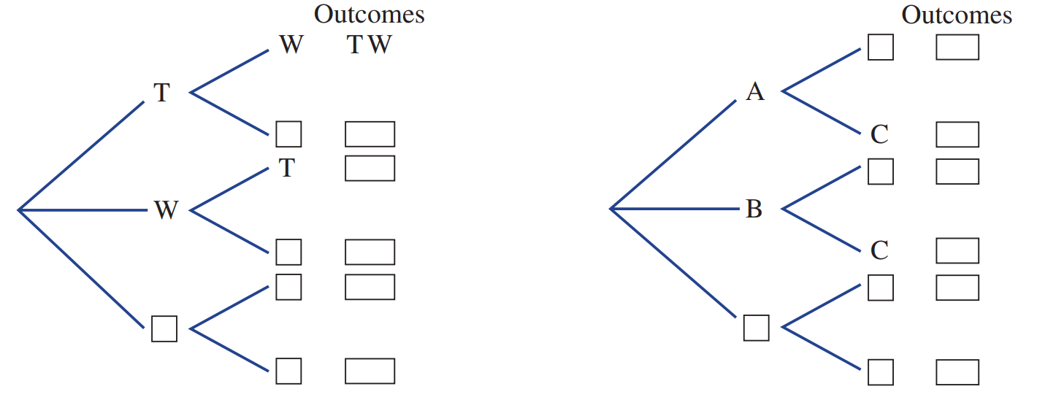  TW, TO, WT, WO, OT, OW | - Selecting two people from a group of three ( A, B and C).  AB, AC, BA, BC, CA, CB
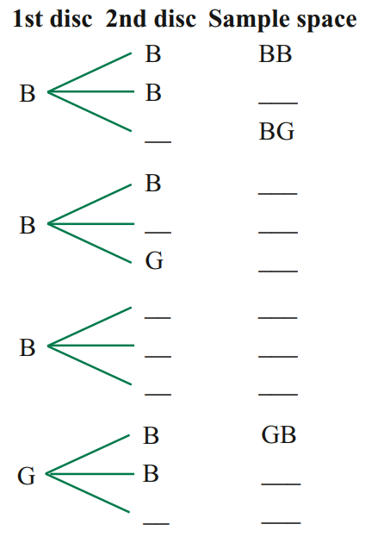
- A bag contains 3 black discs and 1 green disc.
Two discs are selected at random from the bag.
The first disc is not replaced before the second disc is selected.
  - Complete the tree diagram.
  - Calculate the probability that the discs are different colours.

$$\frac{1}{2}$$

Development
- A bag contains one red, one blue and one white marble.
One marble is chosen at random from the bag, and then replaced into the bag.
A second marble is chosen.
  - Draw a tree diagram of the situation.

  - List the outcomes to the right of the branches.
  - Find the probability that:
- both marbles are red  $$\frac{1}{9}$$ | - both marbles are the same colour  $$\frac{1}{3}$$ | - both marbles are different colours  $$\frac{2}{3}$$ | - the first marble is red  $$\frac{1}{3}$$
- there is one blue and one white marble  $$\frac{2}{9}$$ | - exactly one marble is red  $$\frac{4}{9}$$ | - at least one marble is red  $$\frac{5}{9}$$ | - no marbles are blue  $$\frac{4}{9}$$
- A bag contains one red, one blue and one white marble.
One marble is chosen at random from the bag, and NOT replaced into the bag.
A second marble is chosen.
  - Draw a tree diagram of the situation.

  - List the outcomes to the right of the branches.
  - Find the probability that:
- both marbles are red  $$0$$ | - both marbles are the same colour  $$0$$ | - both marbles are different colours  $$1$$ | - the first marble is red  $$\frac{1}{3}$$
- there is one blue and one white marble  $$\frac{2}{6}=\frac{1}{3}$$ | - exactly one marble is red  $$\frac{4}{6}=\frac{2}{3}$$ | - at least one marble is red  $$\frac{4}{6}=\frac{2}{3}$$ | - no marbles are blue  $$\frac{2}{6}=\frac{1}{3}$$
- A spinner with three numbers, 1, 2 and 3, is spun twice.
Each number is equally likely to be spun on a single spin.
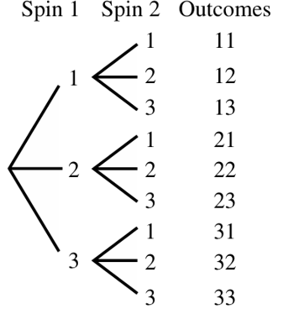
  - List the set of possible outcomes, using a tree diagram.

  - What is the total number of possible outcomes?
9
  - Find the probability of spinning:
- two 3s  $$\frac{1}{9}$$ | - at least one 3  $$\frac{5}{9}$$ | - no more than one 2  $$\frac{8}{9}$$ | - two odd numbers  $$\frac{4}{9}$$

- Two lollipops are selected at random without replacement from a group of three:
strawberry (S), grape (G) and cola (C).
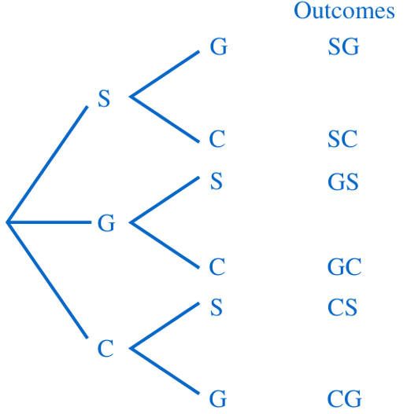
  - List all the possible outcomes for the selection using a tree diagram.

  - Find the probability that the selection will contain:
- strawberry and cola  $$\frac{1}{3}$$ | - grape  $$\frac{2}{3}$$ | - grape or cola  $$1$$

- 2022 HSC Standard 2 Band 4
The numbers 1, 2, 3, 4, 5 and 6 are each written on separate cards.
Amy has cards 1, 3 and 5 and Bob has cards 2, 4 and 6.
They play a game in which each person randomly chooses one of their own cards and compares it with the other person's card. The person with the higher card wins.
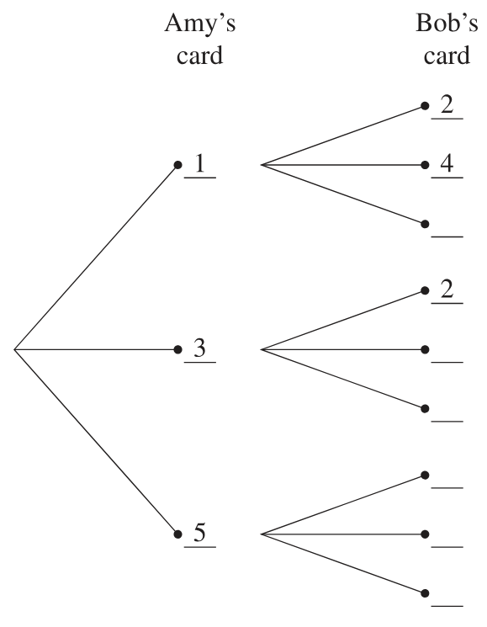
  - Complete the tree diagram and find the probability that Bob wins.

$$\frac{6}{9}=\frac{2}{3}$$
  - Suppose Amy and Bob play this game 30 times.
How many times would Bob be expected to win?

$$30×\frac{2}{3}=20$$

- A three-letter word is chosen in the following way:
The first and last letters are chosen from the three vowels ‘A’, ‘O’ and ‘U’, with no repetition,
and the middle letter is chosen from ‘L’ and ‘M’.
Fill in the tree diagram,
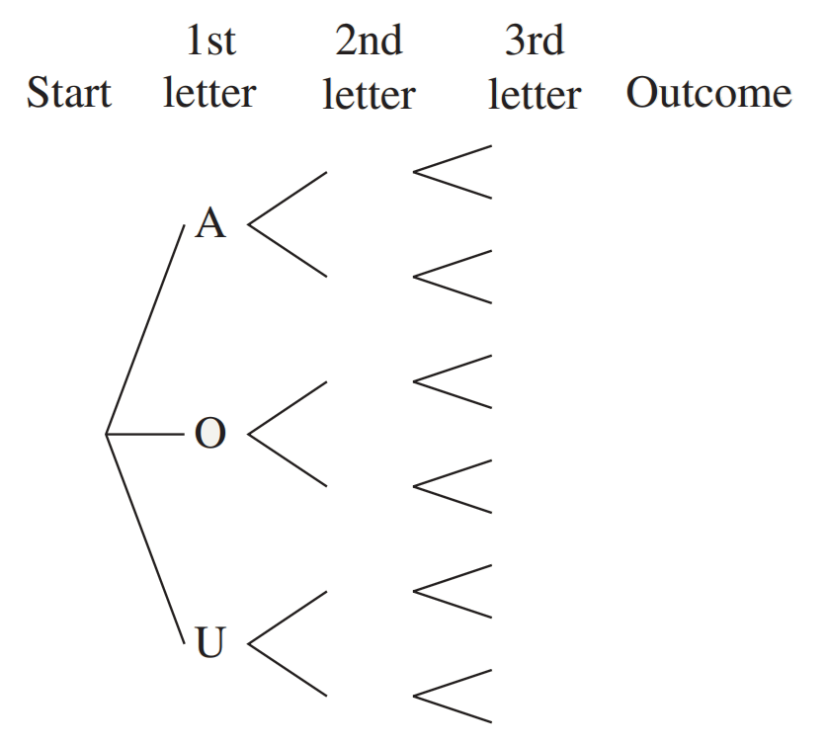

  - Find $P\left(alphabetical order\right)$
$$\frac{1}{2}$$
  - Find $P\left(no 'O"\right)$

$$\frac{1}{3}$$

Multiplication Rule

- Multiplication Rule for Multistage Experiments
If two successive events $A$ and $B$ in a multistage experiment are independent, then:
$$P\left(A and B\right)=P\left(A\right)×P\left(B\right)$$
- We can write $P\left(A and B\right)$ as $P\left(AB\right)$ and $P\left(A,B\right)$ and $P\left(A∩B\right)$.
- Note that $P\left(A and B\right)$ is not always equal to $P\left(B and A\right)$ for multistage probability.

- Example Determine probabilities for independent events using
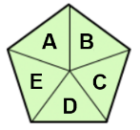  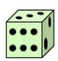  Alex is rolling a dice and spinning a spinner.  What is the probability that he gets:  - 2 on the die and B on the spinner?  $$P\left(2,B\right)=P\left(2\right)×P\left(B\right) \\ =\frac{1}{6}×\frac{1}{5}=\frac{1}{30}$$  - An odd number on the die and a vowel on the spinner?  $$P\left(odd, vowel\right)=P\left(odd\right)×P\left(vowel\right) \\ =\frac{3}{6}×\frac{2}{5}=\frac{6}{30}=\frac{1}{5}$$ | What does $P\left(2 and B\right)$ mean?  Probability of getting ……… in the first stage and ……… in the second stage.  Where did the fractions $\frac{1}{6}$ and $\frac{1}{5}$ come from?  The probability of getting …… is $\frac{1}{6}$  The probability of getting …… is $\frac{1}{5}$  Show why this works using the table.
   | A | B | C | D | E
  1 | 1,A | 1,B | 1,C | 1,D | 1,E
  2 | 2,A | 2,B | 2,C | 2,D | 2,E
  3 | 3,A | 3,B | 3,C | 3,D | 3,E
  4 | 4,A | 4,B | 4,C | 4,D | 4,E
  5 | 5,A | 5,B | 5,C | 5,D | 5,E
  6 | 6,A | 6,B | 6,C | 6,D | 6,E

- Practice
Alison is rolling a die and spinning a spinner.
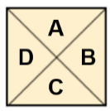

What is the probability that she gets:
- 1 on the die and  C on the spinner.  $$\frac{1}{24}$$ | - An even number and a consonant.  $$\frac{3}{8}$$ | - A number greater than 4 and a vowel.  $$\frac{1}{12}$$

Foundation

  - I roll a fair 6-sided die. What is the probability of scoring a 5?
$$\frac{1}{6}$$
  - I flip a fair coin. What is the probability of getting Tails?
$$\frac{1}{2}$$
  - I do both of the above. What is the probability of getting both a 5 and Tails?
$$\left(\frac{1}{6}\right)\left(\frac{1}{2}\right)=\frac{1}{12}$$
- If I roll two fair, 6-sided dice, what is the probability that both show even numbers?

$$\left(\frac{1}{2}\right)\left(\frac{1}{2}\right)=\frac{1}{4}$$
- Alex has 2 red, 4 blue, 1 yellow and 3 green pens in his pencil case.
He picks a pen at random, draws a circle, then replaces the pen.
Then he does the same for a second circle.
What is the probability that both circles are green?

$$\left(\frac{3}{10}\right)\left(\frac{3}{10}\right)=\frac{9}{100}$$
- There is a $\frac{3}{5}$ probability that I sleep through my alarm.
There is a $\frac{3}{7}$ probability that my bus is late.
What is the probability that I sleep through my alarm and my bus is not late?

$$\left(\frac{3}{5}\right)\left(\frac{4}{7}\right)=\frac{12}{35}$$

- Two marbles are picked at random, one from a bag containing three red and four blue marbles, and the other from a bag containing five red and two blue. Find the probability of:
- Two red marbles  $$\left(\frac{3}{7}\right)\left(\frac{5}{7}\right)=\frac{15}{49}$$ | - Two blue marbles  $$\left(\frac{4}{7}\right)\left(\frac{2}{7}\right)=\frac{8}{49}$$ | - A red from the first bag and blue from second  $$\left(\frac{3}{7}\right)\left(\frac{2}{7}\right)=\frac{6}{49}$$

- A die is rolled twice. Find the probability of:
- A six then a five  $$\left(\frac{1}{6}\right)\left(\frac{1}{6}\right)=\frac{1}{36}$$ | - A one then an odd number  $$\left(\frac{1}{6}\right)\left(\frac{3}{6}\right)=\frac{1}{12}$$ | - A double six  $$\left(\frac{1}{6}\right)\left(\frac{1}{6}\right)=\frac{1}{36}$$
- Two numbers greater than four  $$\left(\frac{2}{6}\right)\left(\frac{2}{6}\right)=\frac{1}{9}$$ | - A number greater than four and then  a number less than four.  $$\left(\frac{2}{6}\right)\left(\frac{3}{6}\right)=\frac{1}{6}$$

- A box contains five light bulbs, two of which are faulty.
Two bulbs are selected, one at a time without replacement. Find the probability that:
- Both bulbs are faulty.  $$\left(\frac{2}{5}\right)\left(\frac{1}{4}\right)=\frac{1}{10}$$ | - Neither bulb is faulty.  $$\left(\frac{3}{5}\right)\left(\frac{2}{4}\right)=\frac{3}{10}$$ | - First bulb is faulty and the second not.  $$\left(\frac{2}{5}\right)\left(\frac{3}{4}\right)=\frac{3}{10}$$
- The second bulb is faulty and the first is not.  $$\left(\frac{3}{5}\right)\left(\frac{2}{4}\right)=\frac{3}{10}$$ | - One of the bulbs is faulty.  $$\frac{3}{10}+\frac{3}{10}=\frac{3}{5}$$ | - At least one bulb is faulty.  $$1 -\frac{3}{10}=\frac{7}{10}$$

- Suppose that A, B, C and D are independent events, with
$$P\left(A\right)=\frac{1}{8}, P\left(B\right)=\frac{1}{3}, P\left(C\right)=\frac{1}{4} and P\left(D\right)=\frac{2}{7}$$
Use the product rule to find:
- P(AB)  $$\frac{1}{24}$$ | - P(AD)  $$\frac{1}{28}$$ | - P(BC)  $$\frac{1}{12}$$
- P(ABC)  $$\frac{1}{96}$$ | - P(BCD)  $$\frac{1}{42}$$ | - P(ABCD)  $$\frac{1}{336}$$

- A coin and a die are tossed. Use the product rule to find the probability of obtaining:
- a three and a head  $$P\left(3 and H\right)= \left(\frac{1}{6}\right)\left(\frac{1}{2}\right)=\frac{1}{12}$$ | - a six and a tail  $$P\left(6 and T\right)= \left(\frac{1}{6}\right)\left(\frac{1}{2}\right)=\frac{1}{12}$$
- an even number and a tail  $$P\left(even and T\right)= \left(\frac{3}{6}\right)\left(\frac{1}{2}\right)=\frac{3}{12}=\frac{1}{4}$$ | - a number less than five and a head  $$P\left(<5 and H\right)= \left(\frac{4}{6}\right)\left(\frac{1}{2}\right)=\frac{4}{12}=\frac{1}{3}$$

- A box of chocolates contains 3 Freddo Frogs and 1 Caramello Koalas.
Two chocolates are taken out of the box without replacement.
  - If the first chocolate was a Freddo Frog,
What is the probability the second chocolate is a Freddo Frog?
$$\frac{2}{3}$$
  - If the first chocolate was a Freddo Frog,
What is the probability the second chocolate is a Caramello Koala?
$$\frac{1}{3}$$
  - If the first chocolate was a Caramello Koala,
What is the probability the second chocolate is Freddo Frog?
$$1$$
  - If the first chocolate was a Caramello Koala,
What is the probability the second chocolate is Caramello Koala?
$$0$$

- A box contains twelve red and ten green discs.
Three discs are selected, one at a time with replacement
  - What is the probability that the discs selected are red, green, red in that order?

$$P\left(R,G,R\right)= \left(\frac{12}{22}\right)\left(\frac{10}{22}\right)\left(\frac{12}{22}\right)=\frac{1440}{10648}=\frac{180}{1331}$$
  - What is the probability of this event if the disc is not replaced after each draw?

$$P\left(R,G,R\right)= \left(\frac{12}{22}\right)\left(\frac{10}{21}\right)\left(\frac{11}{20}\right)=\frac{1320}{9240}=\frac{1}{7}$$

- From a standard deck of 52 cards, two cards are drawn at random with replacement.
Find the probability of drawing:
- A spade then a heart  $$\left(\frac{13}{52}\right)\left(\frac{13}{52}\right)=\frac{1}{16}$$ | - Two clubs  $$\left(\frac{13}{52}\right)\left(\frac{13}{52}\right)=\frac{1}{16}$$
- A jack then a queen  $$\left(\frac{4}{52}\right)\left(\frac{4}{52}\right)=\frac{1}{169}$$ | - The king of diamonds then the ace of clubs.  $$\left(\frac{1}{52}\right)\left(\frac{1}{52}\right)=\frac{1}{2704}$$

- I roll two 6-sided dice, and then add the results.
  - How many ways can I get a total of 4? List them.
(1,3), (2,2), (3,1)
Three ways
  - What is the probability of getting a total of 4?
$$\frac{3}{36}=\frac{1}{12}$$
Or
$$\left(\frac{1}{6}\right)\left(\frac{1}{6}\right)+\left(\frac{1}{6}\right)\left(\frac{1}{6}\right)+\left(\frac{1}{6}\right)\left(\frac{1}{6}\right)=\frac{3}{36}=\frac{1}{12}$$
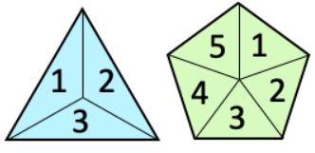
- I spin both these two spinners.

What is the probability that:
- I get 1 on both spinners?  $$\left(\frac{1}{3}\right)\left(\frac{1}{5}\right)=\frac{1}{15}$$ | - I get 2 on both spinners?  $$\left(\frac{1}{3}\right)\left(\frac{1}{5}\right)=\frac{1}{15}$$ | - I get 1 on both spinners or 2 on both spinners?  $$\frac{1}{15}+\frac{1}{15}=\frac{2}{15}$$
- I get the same number on both spinners?  (1,1) (2,2) or (3,3)  $$\frac{3}{15}=\frac{1}{5}$$ | - I get a sum of 3?  2 ways: (1, 2) or (2,1)  $$\frac{2}{15}$$ | - I get a sum of 4?  3 ways: (1,3), (2,2), (3,1)  $$\frac{3}{15}$$

Development
- I roll a fair 6-sided die and spin a spinner. The probability that I get a 6 on the die and 3 on the spinner is $\frac{1}{42}$. What is the smallest number of sides my spinner could have?
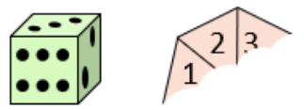

$$\frac{1}{6}×\frac{1}{x}=\frac{1}{42}$$
7
- The probability that on any given day it will rain is ⅓.
The probability that on any given day I will wear my coat is ½.
  - What is the probability of it raining and I wear my coat, assuming these are independent events?

$$\frac{1}{3}×\frac{1}{2}=\frac{1}{6}$$
  - Explain why, in real life, there is not a probability of ⅙ that it rains and I wear my coat.

These are not independent events. I am more liekly to wear my coat if it rains.

  - I flip three fair coins. What is the probability that I get a head on each?

$$\left(\frac{1}{2}\right)\left(\frac{1}{2}\right)\left(\frac{1}{2}\right)=\frac{1}{8}$$
  - I have already flipped two coins and both are heads.
Explain why the probability that the next coin I flip will also be heads is $\frac{1}{2}$.

These are independent events. Probability of heads is always $\frac{1}{2}$
- 2007 HSC Standard 2 Band 4
Each time she throws a dart, the probability that Mary hits the dartboard is $\frac{2}{7}$
She throws two darts, one after the other.
What is the probability that she hits the dartboard with both darts?

$$\left(\frac{2}{7}\right)\left(\frac{2}{7}\right)=\frac{4}{49}$$

Mastery
- 2012 HSC Standard 2 Band 5
Two unbiased dice, each with faces numbered 1, 2, 3, 4, 5, 6, are rolled.
What is the probability of a 6 appearing on at least one of the dice?

$$1-\left(\frac{5}{6}\right)\left(\frac{5}{6}\right)=\frac{11}{36}$$
- 2004 HSC Standard 2 Band 5
Two dice are rolled. What is the probability that only one of the dice shows a six?

$$P\left(6, not 6\right)+P(not 6, 6)$$
$$\left(\frac{1}{6}\right)\left(\frac{5}{6}\right)+\left(\frac{5}{6}\right)\left(\frac{1}{6}\right)=\frac{5}{18}$$
- 2020 HSC Standard 2 Band 5
The top of a rectangular table is divided into 8 equal sections as shown.
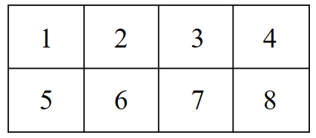

A standard die with faces labelled 1 to 6 is rolled onto the table.
The die is equally likely to land in any of the 8 sections of the table.
If the die does not land entirely in one section of the table, it is rolled again.
A score is calculated by multiplying the value shown on the top face of the die by the number shown in the section of the table where the die lands.
What is the probability of getting a score of 6?
Combinations that score 6: (1,6) (2,3) (3,2) (6,1)
Each combination has $\left(\frac{1}{8}\right)\left(\frac{1}{6}\right)$ chance
$$∴\frac{4}{48}=\frac{1}{12}$$
- 2013 HSC Advanced Band 4
A bag contains 4 red marbles and 6 blue marbles. Three marbles are selected at random without replacement.
What is the probability that at least one of the marbles selected is red?

$$1-P\left(no red\right)$$
$$1-P\left(BBB\right)$$
$$1-\left(\frac{6}{10}\right)\left(\frac{5}{9}\right)\left(\frac{4}{8}\right)=\frac{5}{6}$$

Probability Trees with Independent Events

- Probability Trees with Independent Events
- A probability tree is a tree diagram with probabilities on its branches.
- We use probability trees when each event has a different probability, or when there are too many outcomes to list.
- Calculate an event’s probability by multiplying the probabilities along the branches.

- Interpret probability trees
A bag contains 4 purple and 3 green marbles, and a second bag contains 2 purple and 3 green marbles. A marble is picked out of each bag.
Bag 1 | Bag 2

The tree diagram of this situation is below to the left.
Comment on its appropriateness for representing this problem.

When working with probability, we do not need to list each outcome.
We can calculate the probability of each event instead.
A probability tree shows the events and their probabilities at each stage.
To find the probability of an event, we multiply the probabilities along the branches

Calculate the probability of selecting a green marble and a purple marble, in that order,
using both trees.

Tree diagram listing outcomes |  |  | Probability tree listing events
Bag 1 | Bag 2 | Outcomes | Bag 1 | Bag 2 | Events
P  P  P  P  G  G  G | P  P  G  G  G  P  P  G  G  G  P  P  G  G  G  P  P  G  G  G  P  P  G  G  G  P  P  G  G  G  P  P  G  G  G | PP  PP  PG  PG  PG  PP  PP  PG  PG  PG  PP  PP  PG  PG  PG  PP  PP  PG  PG  PG  GP  GP  GG  GG  GG  GP  GP  GG  GG  GG  GP  GP  GG  GG  GG | $$\frac{4}{7}$$  P  $$\frac{3}{7}$$  G | $$\frac{2}{5}$$  P  $$\frac{3}{5}$$  G  $$\frac{2}{5}$$  P  $$\frac{3}{5}$$  G | $$P\left(PP\right)=$$  $$P\left(PG\right)=$$  $$P\left(GP\right)=$$  $$P\left(GG\right)=$$

- Probability Trees with Independent Events
- Draw a tree diagram where each stage appears as a separate branch.
- Label each branch with the probability of that single-stage event occurring.
- Calculate probability of each event by multiplying probabilities along each path.
- Answer question. When the question asks for multiple events, choose one method:
  - Add the probabilities of all relevant events together, OR
  - Use $1-P(none)$ when the question asks for “at least one.”
- The probabilities on any pair of branches should sum to 1.
- All final events should sum to 1.
- It is a good idea to leave probabilities as unsimplified fractions.

- Example Calculate probability of multistage events using probability trees.
A bag contains 7 red and 5 blue marbles.
A second bag has 4 red and 3 blue.
- What is the probability of drawing a red marble and a blue marble, in any order?
- What is the probability of drawing at least one red marble?
1. Draw tree diagram
1st Stage | 2nd Stage | Events
R  B | R  B  R  B | RR  RB  BR  BB
2. Label branches
3. Calculate probabilities
1st Stage | 2nd Stage | Events
R  $$\frac{3}{7}$$  $$\frac{7}{12}$$  $$\frac{5}{12}$$  B | R  $$\frac{4}{7}$$  B  $$\frac{4}{7}$$  R  $$\frac{3}{7}$$  B | $$P\left(RR\right)=\frac{7}{12}×\frac{4}{7}=\frac{28}{84}$$  $$P\left(RB\right)=\frac{7}{12}×\frac{3}{7}=\frac{21}{84}$$  $$P\left(BR\right)=\frac{5}{12}×\frac{4}{7}=\frac{20}{84}$$  $$P\left(BB\right)=\frac{5}{12}×\frac{3}{7}=\frac{15}{84}$$
4. Answer questions
$$a. P\left(RB\right)+P\left(RB\right)=\frac{21}{84}+\frac{20}{84}=\frac{41}{84}$$
$$b. P\left(RR\right)+P\left(RB\right)+P\left(BR\right)=\frac{28}{84}+\frac{21}{84}+\frac{20}{24}=\frac{69}{84}$$
$$OR: 1-P\left(BB\right)=1-\frac{15}{84}=\frac{69}{84}$$
- Practice
A bag contains 12 green counters and 8 red counters.
Faith removes a counter, writes down its colour then puts it back in the bag.
She then selects another counter and writes down its colour.
- Find the probability that Faith selects two green counters.
- Find the probability that Faith selects at least one green counter.

$$a) \frac{144}{400}=\frac{9}{25}$$
$$b) \frac{336}{400}=\frac{21}{25}$$
Becky has a maths test and then a science test.
She has a 80% chance of passing her maths test.
She has a 60% chance of passing her science test.
- Find the probability she passes only one of the exams.
- Find the probability she passes at least one of the exams.

$$a) 44\%$$
$$b) 92\%$$
- Complementary Events of “At Least One”
The complement of "at least one" is "none".

- Identify the complementary event of “at least one”
Identify the complement of these scenarios.
A coin is flipped four times.  What is the complementary event to  “at least one head”? | You roll a fair six-sided die three times.  What is the complementary event to  "at least one roll is a 6"?
From a shuffled deck of 52 cards, 6 cards are drawn.  What is the complementary event to  "at least one card drawn is a spade"? | You flip a fair coin five times.  What is the complementary event to  "at least one flip results in tails"?
A bag contains 5 red marbles, 3 blue marbles, and 2 green marbles.  Three marbles are drawn.  What is the complementary event to  "at least one marble drawn is red"? | In a class of 30 students, 15 are male and 15 are female. Three students are randomly selected  What is the complementary event to  "at least one student selected is male"?

- Probability of “At Least One”
$$P\left(a least one\right)=1-P\left(none\right)$$

- Interpret the complementary event of “at least one”
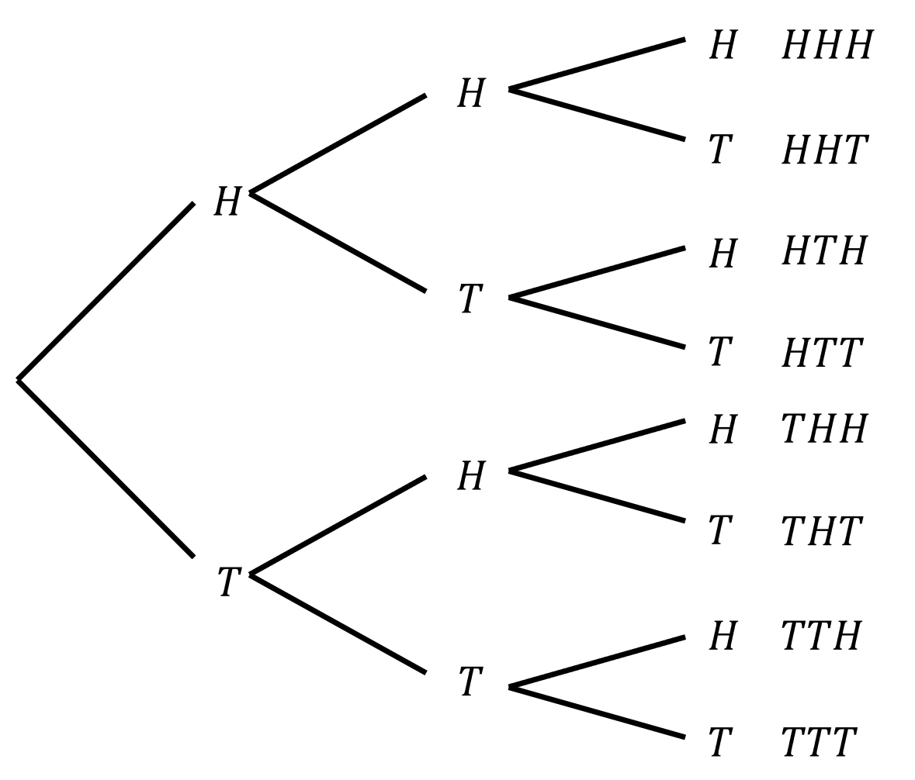
Three coins are flipped. The tree diagram is given.
- What is the probability of no tails?

- What is the probability of at least one tail?

- Does $P\left(at least one\right)=1-P\left(none\right)?$

- A fair die is rolled twice.  What is the probability of no 6s?  What is the probability of at least one 6? | - A spinner has 4 equal sections: red, blue, green, yellow. It's spun 3 times.  What is the probability of no reds?  What is the probability of at least one red?
- A bag contains 3 red balls and 7 blue balls. Two balls are drawn with replacement.  What is the probability of at least one red ball? | - A student guesses on 3 multiple-choice questions. Each question has probability ¼ of being correct.  What is the probability of at least one correct answer?
- A basketball player has a 60% free-throw success rate. She attempts 3 shots.  What is the probability of at least one successful shot? | - A quality control test checks 5 items. Each item has a 5% chance of being defective.  What is the probability of at least one defective item?

Foundation
- The tree diagram below shows the different outcomes when Sophie plays a game of football and a game of rugby.
Which path(s) show the probability of her winning both games?
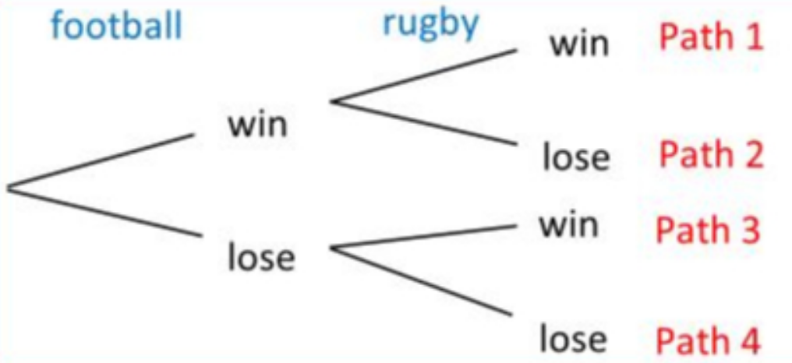

A | Path 1 | B | Path 3 | C | Paths 1 and 3 | D | Paths 1, 2, 3

- The tree diagram below shows the different outcomes when Sophie plays a game of football and a game of rugby.
Which path(s) show the probability of her winning at least one game?

A | Path 1 | B | Path 3 | C | Paths 1 and 3 | D | Paths 1, 2, 3

- The tree diagram below shows the different outcomes when Sophie plays a game of football and a game of rugby.
Which path(s) show the probability of her winning exactly one game?

A | Paths 2 and 3 | B | Path 3 | C | Paths 1 and 3 | D | Paths 1, 2, 3

- The tree diagram below shows the different outcomes when picking two counters out of a bag of red and black counters.
Which path(s) show the probability picking two counters of the same colour?
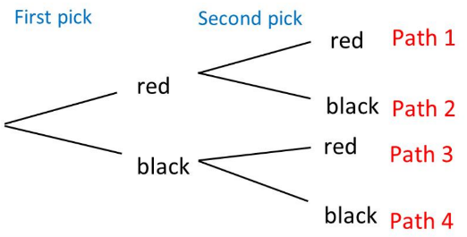

A | Path 1 | B | Paths 1 and 4 | C | Paths 1 and 3 | D | Paths 2 and 3

- A bag contains three black and four white discs. A disc is selected from the bag, its colour is noted, and it is then returned to the bag before a second disc is drawn.
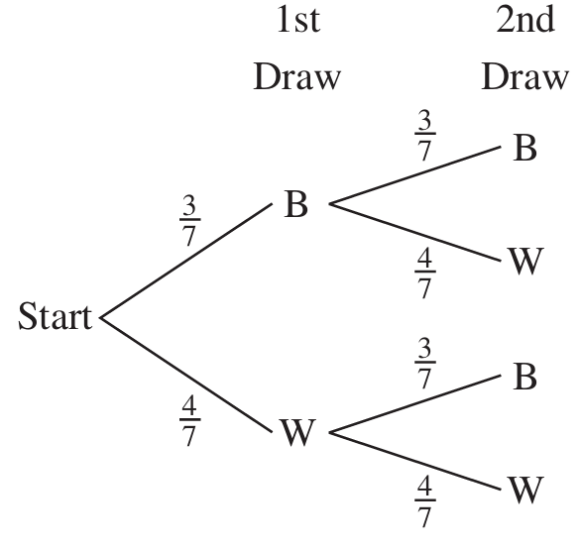
  - By multiplying along the branches of the tree, find:
    - P(BB)
$$\frac{9}{49}$$
    - P(BW)
$$\frac{12}{49}$$
    - P(WB)
$$\frac{12}{49}$$
    - P(WW)
$$\frac{16}{49}$$
  - Hence, by adding, find the probability that:
    - both discs drawn have the same colour,
$$P\left(same colour\right)= P\left(BB\right)+ P\left(WW\right)=\frac{9}{49}+\frac{16}{49}=\frac{25}{49}$$
    - the discs drawn have different colours.
$$P\left(different colours\right)= P\left(BW\right)+ P\left(WB\right)=\frac{12}{49}+\frac{12}{49}=\frac{24}{49}$$

- Two light bulbs are selected at random from a large batch of bulbs in which 5% are defective.
  - By multiplying along the branches of the tree, find:
    - P(both bulbs work),
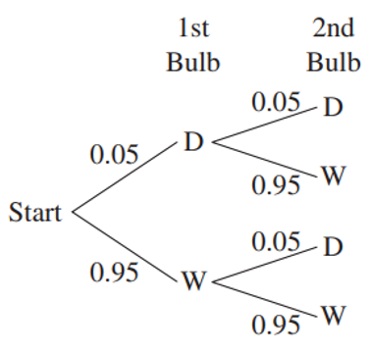
P(both work) = (0.95)(0.95) = 0.9025 = 90.25%
    - P(the first works, but the second is defective),

P(1st works, 2nd defective) = (0.95)(0.05) = 0.0475 = 4.75%
    - P(the first is defective, but the second works),

P(1st defective, 2nd works) = (0.05)(0.95) = 0.0475 = 4.75%
    - P(both bulbs are defective).

P(both defective) = (0.05)(0.05) = 0.0025 = 0.25%
  - Hence find the probability that at least one bulb works.

P(at least one works) = 1 - P(both defective) = 1 - 0.0025 = 0.9975 = 99.75%

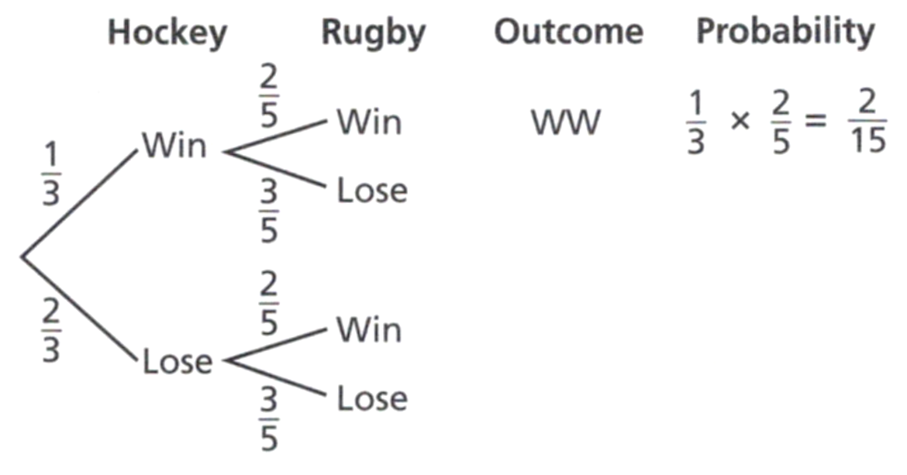
- The probability of Jakub winning a hockey match is $\frac{1}{3}$
The probability of Jakub winning a rugby match is $\frac{2}{5}$
Complete the probability tree diagram.
Find the probability that Jakub:
  - wins exactly one game.

$$\frac{7}{15}$$
  - does not win either game.
$$\frac{6}{15}$$

- A bag contains 3 white and 4 red balls. Another bag contains 2 white and 3 red balls.
A ball is chosen from each bag.
Find the probability of getting:
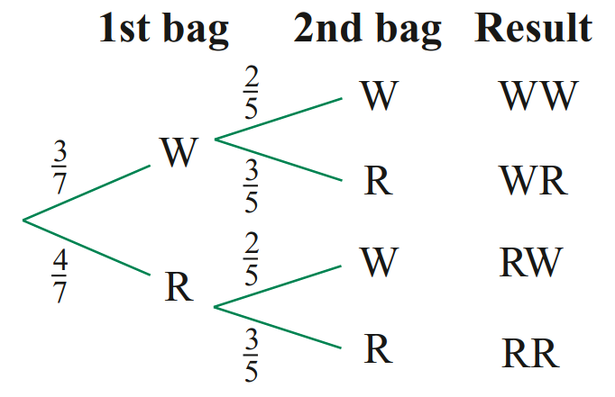
  - 2 white balls
$$\frac{6}{35}$$
  - 2 red balls
$$\frac{12}{35}$$
  - a white and a red ball, in that order
$$\frac{9}{35}$$
  - a white and a red ball, in any order
$$\frac{17}{35}$$
  - at least 1 red ball.
$$\frac{29}{35}$$

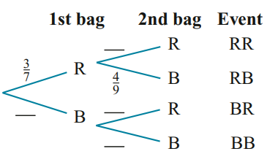
- A bag contains three red and four blue marbles, and a second bag contains 5 red and 4 blue.
A marble is selected from each bag.
  - Complete the probability tree diagram.
  - What is the probability of getting two blue marbles?
$$\frac{16}{63}$$

Development
- One bag contains three red and two blue balls and another bag contains two red and three blue balls. A ball is drawn at random from each bag.
  - Complete the tree diagram by writing the probabilities on the branches.
  - By multiplying along the branches of the tree, find:
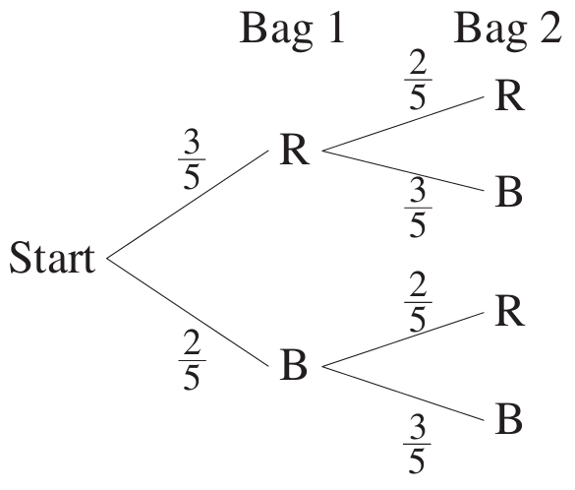
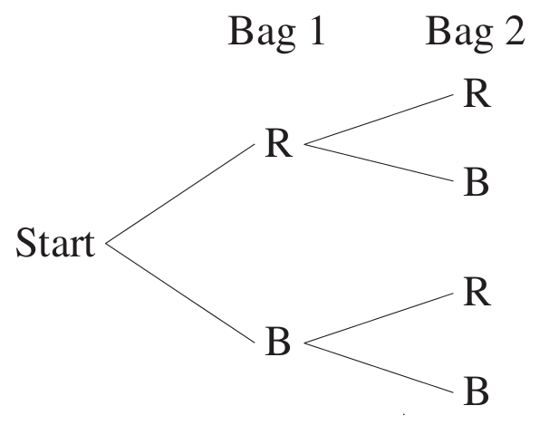
    - P(RR)
$$P\left(RR\right)= \left(\frac{3}{5}\right)\left(\frac{2}{5}\right)=\frac{6}{25}$$
    - P(RB)
$$P\left(RB\right)= \left(\frac{3}{5}\right)\left(\frac{3}{5}\right)=\frac{9}{25}$$
    - P(BR)
$$P\left(BR\right)= \left(\frac{2}{5}\right)\left(\frac{2}{5}\right)=\frac{4}{25}$$
    - P(BB)
$$P\left(BB\right)= \left(\frac{2}{5}\right)\left(\frac{3}{5}\right)=\frac{6}{25}$$
  - Hence, by adding, find the probability that:
    - the balls have the same colour,
$$P\left(RR\right)+ P\left(BB\right)=\frac{6}{25}+\frac{6}{25}=\frac{12}{25}$$
    - the balls have different colours.
$$P\left(RB\right)+ P\left(BR\right)=\frac{9}{25}+\frac{4}{25}=\frac{13}{25}$$

- In group A there are three girls and seven boys, and in group B there are six girls and four boys. One person is chosen at random from each group.
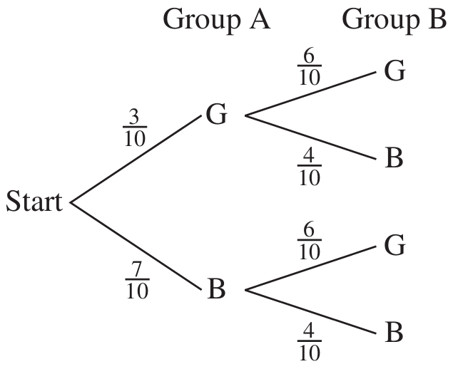
  - Draw a probability tree diagram.

  - By multiplying along the branches of the tree, find:
- P(GG)  $$P\left(GG\right)= \left(\frac{3}{10}\right)\left(\frac{6}{10}\right)=\frac{18}{100}=\frac{9}{50}$$ | - P(GB)  $$P\left(GB\right)= \left(\frac{3}{10}\right)\left(\frac{4}{10}\right)=\frac{12}{100}=\frac{3}{25}$$ | - P(BG)  $$P\left(BG\right)= \left(\frac{7}{10}\right)\left(\frac{6}{10}\right)=\frac{42}{100}=\frac{21}{50}$$ | - P(BB)  $$P\left(BB\right)= \left(\frac{7}{10}\right)\left(\frac{4}{10}\right)=\frac{28}{100}=\frac{7}{25}$$

  - Hence, by adding, find the probability that:
- two boys or two girls are chosen  $$P\left(GG\right)+ P\left(BB\right)=\frac{9}{50}+\frac{14}{50}=\frac{23}{50}$$ | - one boy and one girl are chosen  $$P\left(GB\right)+ P\left(BG\right)=\frac{6}{50}+\frac{21}{50}=\frac{27}{50}$$
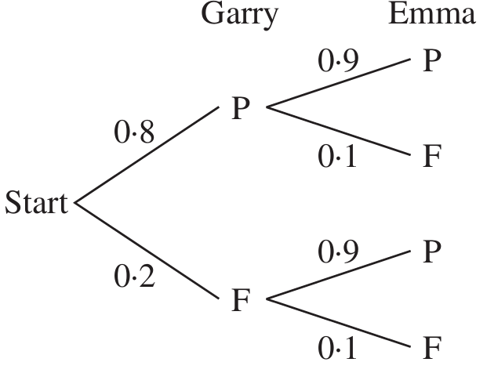
- There is an 80% chance that Garry will pass his driving test and a 90% chance that Emma will pass hers.
Draw a probability tree diagram.

find the chance that
- Garry passes and Emma fails  $$\left(0.8\right)\left(0.1\right)= 0.08 = 8\%$$ | - Garry fails and Emma passes  $$\left(0.2\right)\left(0.9\right)= 0.18 = 18\%$$
- only one of Garry and Emma passes  $$8\% + 18\% = 26\%$$ | - at least one fails  $$1 - P\left(both pass\right)= 1 - \left(0.8\right)\left(0.9\right)= 28\%$$

- A student enters the 100 m and 400 m events at the school swimming carnival.
Her chance of winning the 100 m event is 0.8 and her chance of winning the 400 m event is 0.6.
  - Draw a probability tree showing the possible results for each event and the combined results.

  - Calculate the probability that she will (answer as a decimal):
    - win both events.
0.48
    - not win either event.
0.08
    - win the 100 m but not win the 400 m.
0.32
    - win at least one event.
0.92

- A council is running two raffles. The probability of winning in each raffle is 1 in 100.
Jared buys one ticket for each raffle. Answer these questions without drawing a tree diagram.
  - What is the probability that he wins both?
$$\frac{1}{100}×\frac{1}{100}=\frac{1}{10000}$$
  - What is the probability he wins at least one?
$$1-\left(\frac{99}{100}×\frac{99}{100}\right)=\frac{199}{10000}$$

- A magician deals cards from two different decks for a trick.
The probability of dealing a red card from deck 1 is 0.3.
The probability of a red card from deck 2 is three times the probability of a red from deck 1.
  - What is the probability of picking two reds?
$$0.27$$
  - What is the probability of picking a red from deck 1
and a black from deck 2?
$$0.03$$
  - What is the probability of picking a black from deck 1
and a red from deck 2?
$$0.63$$
  - What is the probability of picking no reds?
$$0.07$$

- The probability that a set of traffic lights will be green when you arrive at them is 0.6.
A motorist drives through two sets of lights. Assuming that the two sets of traffic lights are independent of each other, find the probability that:
  - both sets of lights will be green,
  - at least one set of lights will be green.

$$a) P\left(both green\right)= \left(\frac{3}{5}\right)\left(\frac{3}{5}\right)=\frac{9}{25}$$
$$b) P\left(at least one green\right)= 1 - P\left(both not green\right)= 1 - \left(\frac{2}{5}\right)\left(\frac{2}{5}\right)= 1 -\frac{4}{25}=\frac{21}{25}$$

- A factory assembles calculators. Each calculator requires a chip and a battery.
It is known that 1% of chips and 4% of batteries are defective.
Find the probability that a calculator selected at random will have at least one defective component.

P(at least one defective) = 1 - P(both work) = 1 - (0.99)(0.96) = 1 - 0.9504 = 0.0496 = 4.96%
- The probability of a woman being alive at 80 years of age is 0.2, and the probability of her husband being alive at 80 years of age is 0.05. Find the probability that:
  - they will both live to be 80 years of age,
  - only one of them will live to be 80.

a) P(both alive at 80) = (0.2)(0.05) = 0.01
b) P(only one alive at 80) = (0.2)(0.95) + (0.8)(0.05) = 0.19 + 0.04 = 0.23

- When a child is born, the probability of a boy is 0.51 and the probability of a girl is 0.49.
Draw a probability tree diagram for a family’s two children.
  - Calculate the probability, as a decimal:
    - Two boys
0.2601
    - A boy then a girl, in that order.
0.2499
    - A girl and a boy, in any order.
0.4998
    - At least one girl.
0.7399

Mastery
- 2016 HSC Standard 2 Band 5
A cricket team is about to play two matches. The probability of the team having a win, a loss or a draw is 0.7, 0.1 and 0.2 respectively in each match. The possible results in the two matches are displayed in the probability tree diagram.
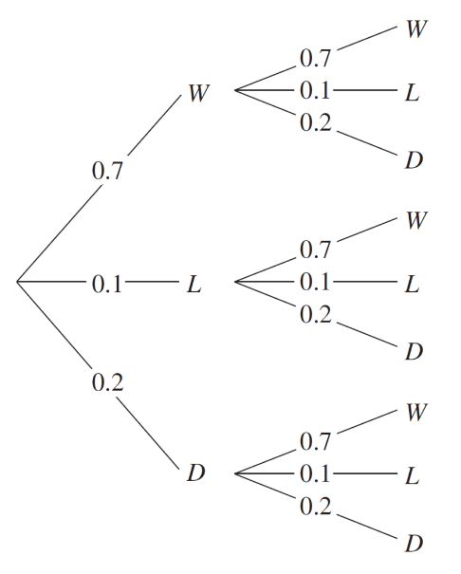
  - What is the probability of the team having a win and a draw, in any order?

$$0.28$$
  - Paul claims that 1.4 is the probability of the team winning both matches.
Give one reason why this is NOT correct.

Probability cannot be greater than one.
He added instead of multiplying along the branches.

- 2007 HSC Standard 2 Band 5
In a stack of 10 DVDs, there are 5 rated PG, 3 rated G and 2 rated M
Grant chooses two DVDs at random from the stack.
Calculate the probability that Grant chooses two DVDs with the same rating.
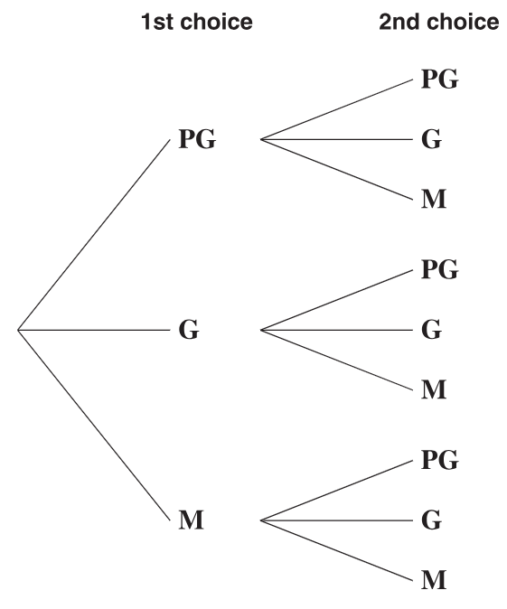

$$\frac{14}{45}$$

- Max and Jack each throw a die. Find the probability that:
  - they do not throw the same number,
  - the number thrown by Max is greater than the number thrown by Jack,
  - the numbers they throw differ by three.

A two-way table is useful for this question.
$$P\left(different numbers\right)= 1 - P\left(same\right)= 1 -\frac{6}{36}=\frac{30}{36}=\frac{5}{6}$$
$$P\left(Max > Jack\right)=\frac{15}{36}=\frac{5}{12}$$
$$P\left(differ by 3\right)=\frac{6}{36}=\frac{1}{6}$$

- A game is played in which two coloured dice are rolled once.
The six faces of the black die are numbered 5, 7, 8, 10, 11, 14.
The six faces of the white die are numbered 3, 6, 9, 12, 13, 15.
The player wins if the number on the black die is bigger than the number on the white die.
  - Calculate the probability of a player winning the game.
  - Calculate the probability that a player will lose at least once in two consecutive games.
  - How many games must be played before you have a 90% chance of winning at least one game? (hint: set up an equation and use logarithms)

A two-way table is useful for this question
$$P\left(win\right)=\frac{16}{36}=\frac{4}{9}$$
$$P\left(lose at least once in 2 games\right)= 1 - P\left(win both\right)$$
$$= 1 - {\left(\frac{4}{9}\right)}^{2}= 1 -\frac{16}{81}=\frac{65}{81}$$

$$P(win at least once in n games) ≥ 0.9$$
$$1 - {\left(\frac{5}{9}\right)}^{n} ≥ 0.9$$
$${\left(\frac{5}{9}\right)}^{n} ≤ 0.1$$
$$n ≥\log_{\frac{5}{9}}{0.1}≥3.917…$$
$$∴4 games or more$$
Note: we flip the inequality when taking a log of a base that is less than one.
You do not need to know this fact; intuitively, it must be more than 4 games, not less than 4.

- 2008 HSC Advanced Band 5
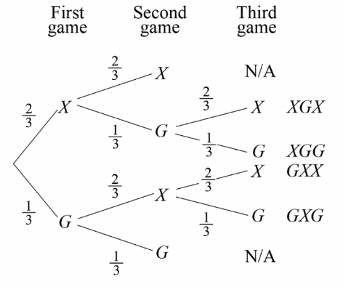
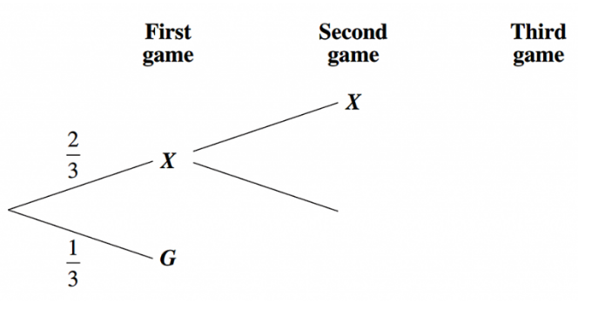
Xena and Gabrielle compete in a series of games. The series finishes when one player has won two games. In any game, the probability that Xena wins is $\frac{2}{3}$ and the probability that Gabrielle wins is $\frac{1}{3}$. Part of the tree diagram for this series of games is shown.

  - Complete the tree diagram, showing the possible outcomes (there are only 6).
  - What is the probability Gabrielle wins the series?
$$P\left(XGG\right)+P\left(GXG\right)+P\left(GG\right)=\frac{2}{27}+\frac{2}{27}+\frac{1}{9}=\frac{7}{27}$$
  - What is the probability three games are played in the series?
$$1-\left(P\left(XX\right)+P\left(GG\right)\right)=1-\left(\frac{4}{9}+\frac{1}{9}\right)=\frac{4}{9}$$

Probability Trees with Dependent Events

- Probability Trees with Dependent Events
- Dependent events occur when there is no replacement.
- Draw a tree diagram where each stage appears as a separate branch.
- Label each branch with the probability of that single-stage event occurring.
- Calculate probability of each event by multiplying probabilities along each path.
- Answer question. When the question asks for multiple events, choose one method:
  - Add the probabilities of all relevant events together, OR
  - Use $1-P(none)$ when the question asks for “at least one.”
- The probabilities on any pair of branches should sum to 1.
- All final events should sum to 1.
- It is a good idea to leave probabilities as unsimplified fractions.

- Example Calculate probability of multistage events using probability trees.
A bag contains 3 red marbles and 5 blue marbles.
Two are taken from the same bag without replacement.
- What is the probability of drawing a red marble and a blue marble, in any order?
- What is the probability of drawing at least one red marble?

1st Stage | 2nd Stage | Events
R  $$\frac{5}{7}$$  $$\frac{3}{8}$$  $$\frac{5}{8}$$  B | R  $$\frac{2}{7}$$  B  $$\frac{4}{7}$$  R  $$\frac{4}{7}$$  B | $$P\left(RR\right)=\frac{3}{8}×\frac{2}{7}=\frac{6}{56}$$  $$P\left(RB\right)=\frac{3}{8}×\frac{5}{7}=\frac{15}{56}$$  $$P\left(BR\right)=\frac{5}{8}×\frac{3}{7}=\frac{15}{56}$$  $$P\left(BB\right)=\frac{5}{8}×\frac{4}{7}=\frac{20}{56}$$

$$a. P\left(RB\right)+P\left(RB\right)=\frac{15}{56}+\frac{15}{56}=\frac{30}{56}$$
$$b. P\left(RR\right)+P\left(RB\right)+P\left(BR\right)=\frac{6}{56}+\frac{15}{56}+\frac{15}{56}=\frac{36}{56}=\frac{9}{14}$$
$$OR: 1-P\left(BB\right)=1-\frac{20}{56}=\frac{9}{14}$$

- Practice
A bag contains 4 black counters and 8 white counters.
Hannah takes two counters out of the bag at random without replacing the first.
- Find the probability that Hannah selects two counters of the same colour.
- Find the probability that Hannah selects at least one white counter.

$$a) \frac{68}{132}=\frac{17}{33}$$
$$b) \frac{120}{132}=\frac{10}{11}$$
A box contains 2 milk chocolates and 7 dark chocolates.
Miki selects a chocolate at random, eats it, and selects a second.
Find the probability:
- She picks two milk chocolates.
- Two different types of chocolates.
- Two chocolates of the same type.
- At least one dark chocolate.

$$a)\frac{2}{72}=\frac{1}{36}$$
$$b)\frac{28}{72}=\frac{7}{18}$$
$$c)\frac{44}{72}=\frac{11}{18}$$
$$d)\frac{70}{72}=\frac{35}{36}$$

Foundation
- There are 8 cookbooks and 13 maths books on a bookshelf.
Two books are selected at random from the bookshelf.
  - The first book is replaced before the second book is selected.
Complete to find the probability that the books are the same type.
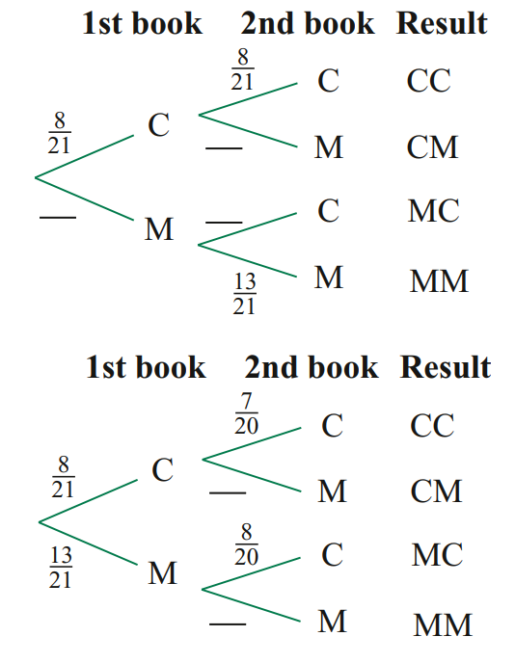
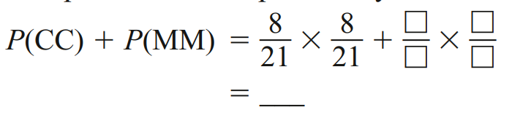

$$\frac{233}{441}$$
  - The first book is not replaced before the second book is selected.
Complete to find the probability that the books are the same type.
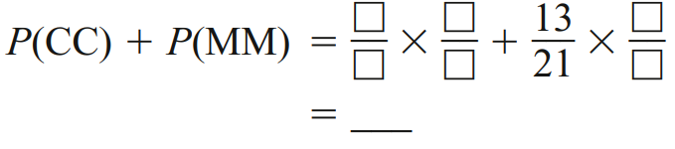

$$\frac{53}{105}$$
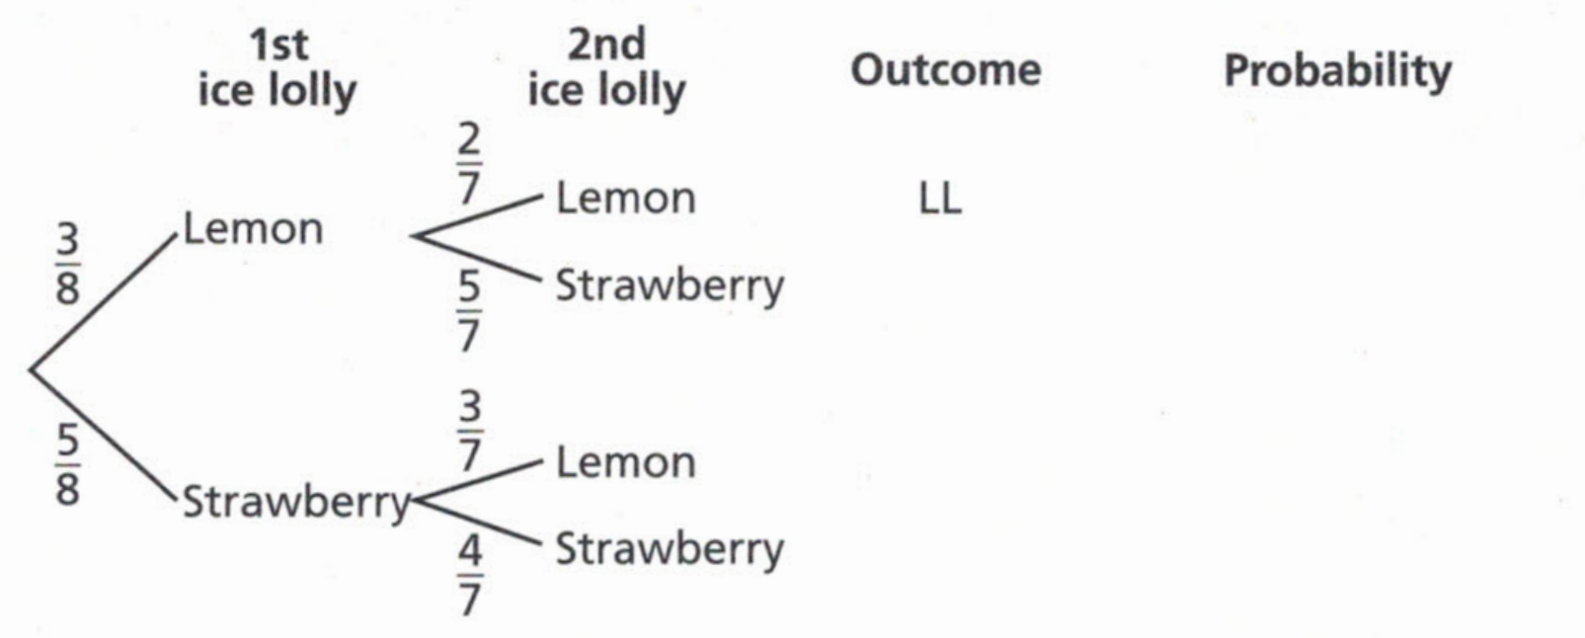
- A freezer contains 3 lemon ice lollies and 5 strawberry ice lollies.
Two ice lollies are selected at random without replacement.
Complete the probability tree diagram

Find the probability that
  - both ice lollies are strawberry
$$\frac{5}{14}$$
  - at least one ice lolly is strawberry.
$$\frac{25}{28}$$

Development
- A jar contains 7 red discs and 3 blue discs.
Another jar contains 4 red discs and 5 blue discs.
A disc is chosen from each jar.
  - Complete the probability tree diagram.
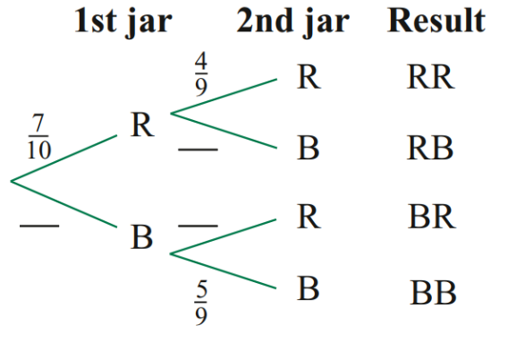
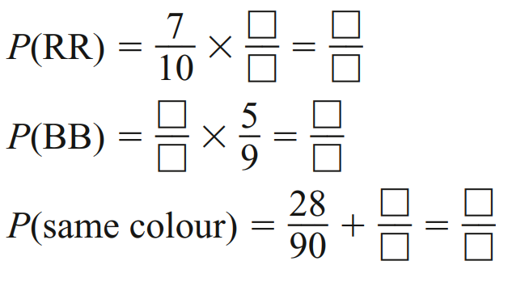
  - Complete to calculate the probability that the discs
chosen are the same colours.

$$\frac{28}{90}$$
$$\frac{15}{90}$$
$$\frac{43}{90}$$

- A bag contains 5 blue (B) and 3 white (W) marbles.
Mary picks 2 marbles without replacement.
  - Complete the tree diagram by writing the probabilities on the branches and the probability of each event.
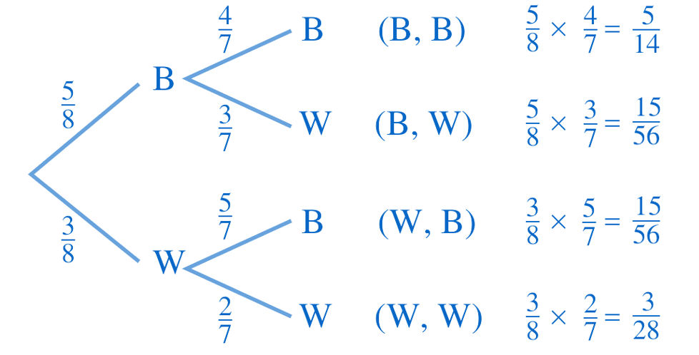
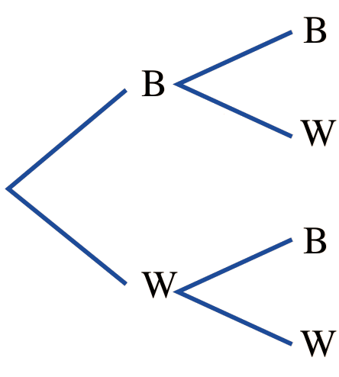

  - Find the probability of selecting:
- Two blue marbles  $$\frac{5}{14}$$ | - A blue and a white in that order  $$\frac{15}{56}$$ | - One of each colour  $$P\left(BW\right)+P\left(WB\right)=\frac{30}{56}=\frac{15}{28}$$ | - At least one blue marble  $$1-P\left(WW\right)=\frac{25}{28}$$

- Two animals are selected from rabbits (R) and 4 guinea pigs (G) without replacement.
Draw a tree diagram and the find the probability of each possible event.
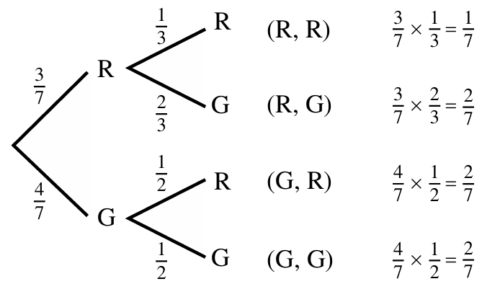

What is the probability of selecting
- 1 of each animal  $$P\left(RG\right)+P\left(GR\right)=\frac{4}{7}$$ | - 2 of the same animal  $$P\left(RR\right)+P\left(GG\right)=\frac{3}{7}$$
- No rabbits  $$P\left(GG\right)=\frac{2}{7}$$ | - At least one rabbit  $$1-P\left(GG\right)=\frac{5}{7}$$

- A bag contains 3 red and 4 white counters. Two are taken without replacement.
  - Draw a tree diagram and label the branches with the corresponding probability.

  - What is the probability of picking exactly one white counter?
$$\frac{4}{7}$$
  - What is the probability of picking exactly one red counter?
$$\frac{4}{7}$$
  - What is the probability of picking no red balls?
$$\frac{2}{7}$$
  - What is the probability of picking at least one red?
$$\frac{5}{7}$$

- There are 12 novels and 9 science books on a bookshelf. Two books are selected at random from the bookshelf.
  - The first book is replaced before the second book is selected.
Draw a tree diagram

Find the probability of choosing:
    - novel and then a science book.
$$\frac{12}{49}$$
    - 2 novels.
$$\frac{16}{49}$$
    - at least one science book.
$$\frac{33}{49}$$
  - The first book is NOT replaced before the second book is selected.
Draw a tree diagram.

Find the probability of choosing:
    - novel and then a science book.
$$\frac{9}{35}$$
    - 2 novels.
$$\frac{11}{35}$$
    - at least one science book.

$$\frac{24}{35}$$
- There are 4 green and 7 pink counters in a bag. Two are picked at random.
Counters are not replaced after each pick. What is the probability of picking at least one pink?

$$\frac{49}{55}$$

- I have a 6-sided die and a coin.
  - You roll the die twice. Draw a tree diagram to calculate the probability you get exactly 1 six.

$$\frac{5}{18}$$
  - If you roll the die 72 times, how many sixes would you expect to get?

12
  - You flip the coin and roll the die.
Draw a two-way table to find the probability you get tails and an even number.
 | 1 | 2 | 3 | 4 | 5 | 6
Heads | H1 | H2 | H3 | H4 | H5 | H6
Tails | T1 | T2 | T3 | T4 | T5 | T6
$$\frac{1}{4}$$
  - You flip the coin 3 times.
List all the possible outcomes and find the probability of getting at least 1 head.

$$\frac{7}{8}$$
  - How could you use complementary events to calculate the answer to part d quickly?

$$1 - P\left(no heads\right)=1-P(all tails)$$
$$\frac{7}{8}$$

Mastery
- There are $x$ green and $y$ pink counters in a bag. Two are picked at random.
Counters are not replaced after each pick.
What probability should be written in space 𝐴 and 𝐵 on the tree diagram?
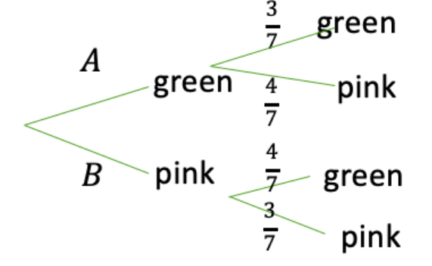

$$A=\frac{4}{8}, B=\frac{4}{8}$$
- There are 3 yellow and 5 white counters in a bag.
Three are picked at random. Counters are not replaced after each pick.
What is the probability of picking three of the same colour?

$$\frac{11}{56}$$
- There are 3 grey, 2 yellow and 5 white counters in a bag.
Three are picked at random. Counters are not replaced after each pick.
What is the probability of picking two greys and a white?

$$\frac{1}{8}$$
- 2022 HSC Standard 1
A jar contains 12 red, 10 black and 13 white lollies.
Alex picks out a red lolly and eats it. He then randomly picks a second lolly.
What is the probability that the second lolly is also red?

$$\frac{11}{34}$$
- 2021 HSC Standard 2 Band 5
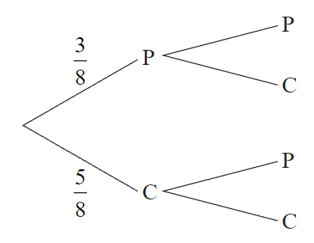
A box has 8 chocolates. 3 have peppermint centres (P) and 5 have caramel centres (C).
Kim randomly chooses a chocolate from the box and eats it.
Sam then randomly chooses and eats one of the remaining chocolates.
A partially completed probability tree is shown.
What is the probability that Kim and Sam choose
chocolates with different centres?

$$\frac{15}{28}$$
- 2019 HSC Standard 2 Band 5
A bowl of fruit contains 17 apples of which 9 are red and 8 are green.
Dennis takes one apple at random and eats it.
Margaret also takes an apple at random and eats it.
By drawing a probability tree diagram, or otherwise, find the probability that Dennis and Margaret eat apples of the same colour.

$$\frac{8}{17}$$
- 2023 HSC Standard 2 Band 4
One hundred tickets are sold in a raffle which offers two prizes.
Hazel buys five of the tickets.
A ticket is drawn at random for the first prize.
A second ticket is drawn from the remaining tickets for the other prize.
What is the probability that Hazel wins both prizes?

$$\frac{1}{495}$$
- 2017 HSC Standard 2 Band 6
A deck of 52 playing cards contains 12 picture cards.
Two cards from the deck are drawn at random and placed on a table.
What is the probability, correct to four decimal places, that exactly one picture card is on the table?
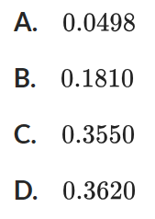

D
- In a raffle in which there are 200 tickets, the first prize is drawn and then the second prize is drawn without replacing the winning ticket. If you buy 15 tickets, find the probability that you win:
  - both prizes,
  - at least one prize.

$$P\left(both prizes\right)= \left(\frac{15}{200}\right)× \left(\frac{14}{199}\right)=\frac{210}{39800}=\frac{21}{3980}$$
$$P(at least one) = 1 - P(no prizes)= 1 - \left(\frac{185}{200}\right)× \left(\frac{184}{199}\right)= \frac{144}{995}$$
- A box contains 10 chocolates, all of identical appearance. Three of the chocolates have caramel centres and the other seven have mint centres. Hugo randomly selects and eats three chocolates from the box. Find the probability that:
  - the first chocolate Hugo eats is caramel,
  - Hugo eats three mint chocolates,
  - Hugo eats exactly one caramel chocolate.

$$P\left(1st is caramel\right)=\frac{3}{10}$$
$$P\left(three mint\right)= \left(\frac{7}{10}\right)× \left(\frac{6}{9}\right)× \left(\frac{5}{8}\right)=\frac{210}{720}=\frac{7}{24}$$
$$P\left(exactly one caramel\right)= 3 × \left(\frac{3}{10}\right)× \left(\frac{7}{9}\right)× \left(\frac{6}{8}\right)=\frac{378}{720}=\frac{21}{40}$$
- In an aviary there are four canaries, five cockatoos and three budgerigars. If two birds are selected at random, find the probability that:
  - both are canaries,
  - neither is a canary,
  - one is a canary and one is a cockatoo,
  - at least one is a canary.

$$P\left(both canaries\right)= \left(\frac{4}{12}\right)× \left(\frac{3}{11}\right)=\frac{12}{132}=\frac{1}{11}$$
$$P\left(neither canary\right)= \left(\frac{8}{12}\right)× \left(\frac{7}{11}\right)=\frac{56}{132}=\frac{14}{33}$$
$$P\left(one canary, one cockatoo\right)= 2 × \left(\frac{4}{12}\right)× \left(\frac{5}{11}\right)=\frac{40}{132}=\frac{10}{33}$$
$$P\left(at least one canary\right)= 1 - P\left(neither canary\right)= 1 -\frac{14}{33}=\frac{19}{33}$$

- An interviewer conducts a poll in Sydney and Melbourne on the popularity of the prime minister. In Sydney, 52% of the population approve of the prime minister, and in Melbourne her approval rating is 60%. If one of the two capital cities is selected at random and two electors from that city are surveyed, find the probability that:
  - both electors approve of the prime minister,
  - at least one elector approves of the prime minister.

A three-stage tree diagram is needed here.

$$a) P\left(Syd,Approve,Approve\right)+P\left(Mel, Approve,Approve\right)=\left(0.5\right)\left(0.52\right)\left(0.52\right)+\left(0.5\right)\left(0.6\right)\left(0.6\right)=31.52\%$$

$$b) 1-P\left(both disapprove\right)=1-\left(P\left(Syd, Disapprove,Disapprove\right)+P\left(Mel,Disapprove,Disapprove\right)\right)$$
$$=1-\left(\left(0.5\right)\left(0.48\right)\left(0.48\right)+\left(0.5\right)\left(0.4\right)\left(0.4\right)\right)$$
$$=80.48\%$$

- In a bag there are four green, three blue and five red discs.
Two discs are drawn at random, and the first disc is not replaced before the second disc is drawn. Find the probability of drawing:
  - two red discs,
  - one red and one blue disc,
  - at least one green disc,
  - a blue disc on the first draw,
  - two discs of the same colour,
  - two differently coloured discs.
$$P\left(two red\right)= \left(\frac{5}{12}\right)\left(\frac{4}{11}\right)=\frac{20}{132}=\frac{5}{33}$$

$$P\left(one red, one blue\right)= \left(\frac{5}{12}\right)\left(\frac{3}{11}\right)+ \left(\frac{3}{12}\right)\left(\frac{5}{11}\right)=\frac{30}{132}=\frac{5}{22}$$

$$P\left(at least one green\right)= 1 - P\left(no green\right)= 1 - \left(\frac{8}{12}\right)\left(\frac{7}{11}\right)= 1 -\frac{56}{132}=\frac{76}{132}=\frac{19}{33}$$

$$P\left(blue first\right)=\frac{3}{12}=\frac{1}{4}$$

$$P(same colour) = P(two green) + P(two blue) + P\left(two red\right)$$
$$= \left(\frac{4}{12}\right)\left(\frac{3}{11}\right)+ \left(\frac{3}{12}\right)\left(\frac{2}{11}\right)+ \left(\frac{5}{12}\right)\left(\frac{4}{11}\right)=\frac{19}{66}$$

$$P\left(different colours\right)= 1 - P\left(same colour\right)= 1 -\frac{19}{66}=\frac{47}{66}$$

- HSC Advanced Sample Question Band 5
A box contains $n$ marbles, of which $k$ marbles are coloured red and the remainder of the marbles are coloured green. Two marbles are drawn randomly from the box.
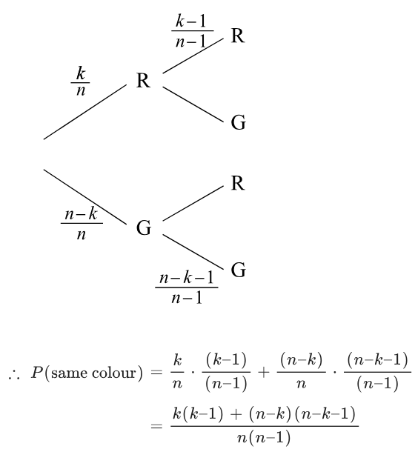
If the first marble is not replaced into the box before the second marble is drawn, then the probability that the two marbles drawn are the same colour is:
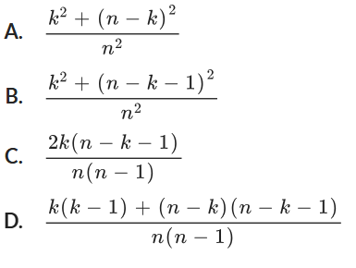

D

